LAB – 2

1)

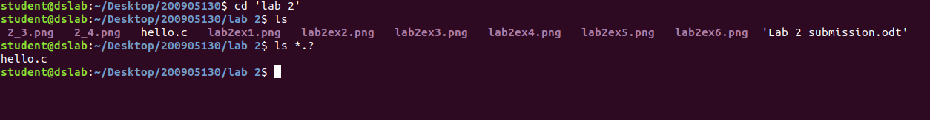

2)
cat > file1.txt
lkl
jhvjhv
hgcmc
cat > file2.txt
dqdwe
wqe

cat > script.sh
cd $1
ls $2

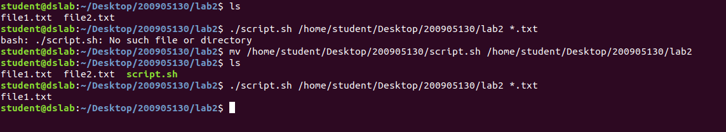

3)
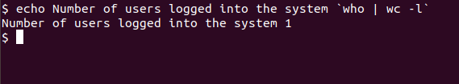

4)
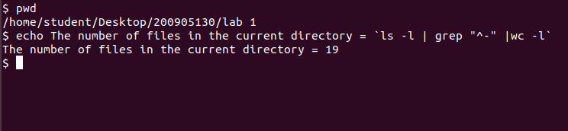

5)

cat > num1.txt
1
2
3
cat > num2.txt
3
4
5
cat > scripture.sh
cat $1 $2 > num3.txt
sort num3.txt > sorted.txt
uniq sorted.txt output.txt
cat output.txt

$ ./scripture.sh num1.txt num2.txt

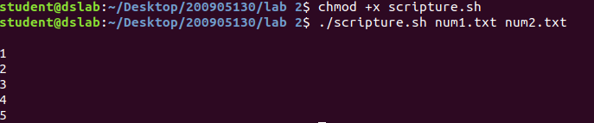

6)

cat > file3.sh
cp $1 $2
